|  |  |
| --- | --- |
| Course Name | ITD 3243 – Server Side Programming |
| Instructor | Mark L. Pranger |
| Student Name | Sharyl Hammer |
| Due date | January 25, 2018 |
| Grade | 100 |
| Grading Comments |  |

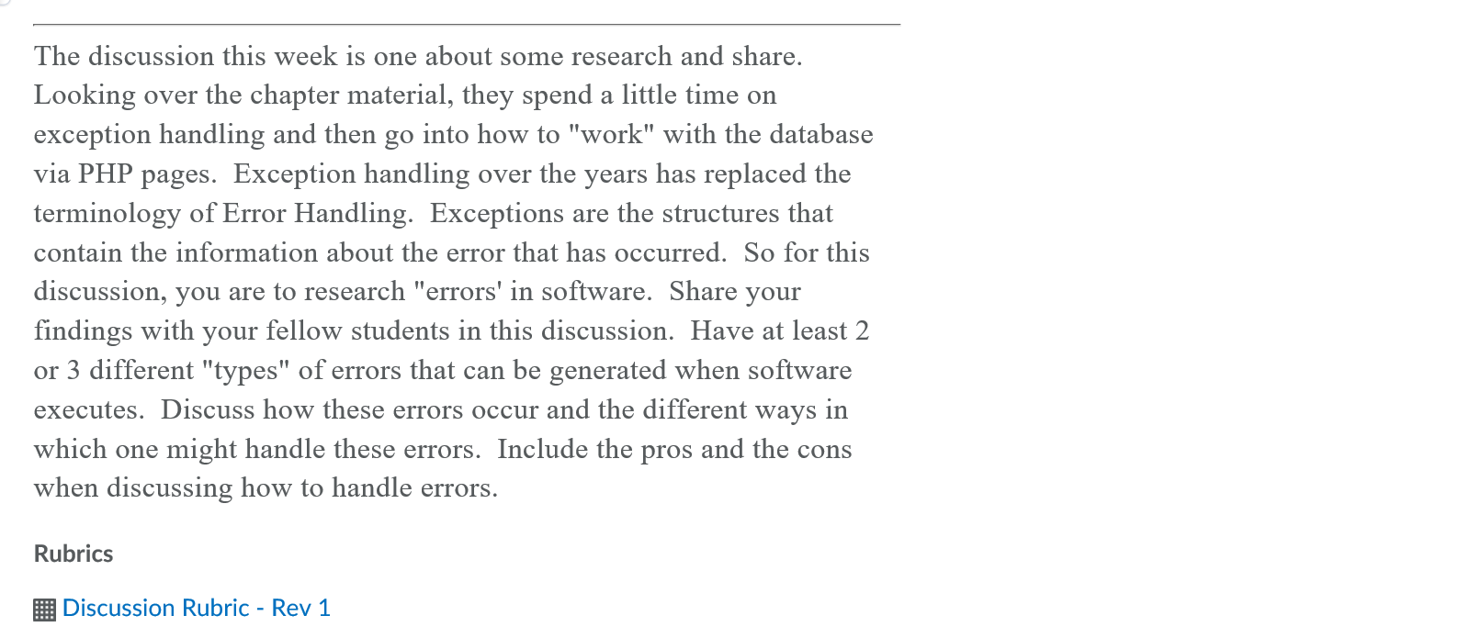

Common Categories of Software Errors

**Functionality Errors**

Functionality Errors is when something that is expected is hard, awkward confusing or impossible.

Example: When the user selects to upload a file and then decides to cancel and the cancel button is not clickable this is a functionality error.

To prevent a functionality error the programmer needs to test all buttons on the screen and make sure each button is accessible. This type of error causes the user to close the web-site to cancel the functionality of the upload. This type of error is not a production stopper but prevents the program from being cancelled correctly with the use of the cancel button.

When a user accesses a program that does not have full functionality of the command buttons this causes confusion to the user.

**Syntactic Errors**

Syntactic errors are misspelled words or grammatically incorrect sentences which are very evident while testing software interface screens.

Example: The cancel button text is misspelled to be CANCLE. This type of error can be easily fixed by the programmer spelling the text correctly as CANCEL. Before the programmer launches a program in production he or she should verify that the text is spelled correctly and is easily understood by the user.

This type of error can cause confusion to the user to not fully understand the sentence structure of instructions or when a word is misspelled this can cause confusion to the user also. This type of error is not a show stopper and can be easily fixed by the text being changed in the code.